**FITFLEX Project Documentation**

**Project Title** : *FITFLEX* (Flexibility & Fitness Made Easy)

**Team ID** : *NM2025TMIFD39052*

**Team Leader** :

* *Gwyneth Wingwell (24bsccs45@cttewc.edc.in)*

**Team Members** :

* *Sakthi Sri K (24bsccs33@cttewc.edu.in)*
* *Deepalakshmi S (24bsccs13@cttewc.edu.in)*
* *Keerthika k (24bsccs52@cttewc.edu.in)*

**1.project overview**

**Purpose:** *“FitFlex” is a fitness / wellness platform (app / service) that aims to allow*

*users to achieve their health,strength, flexibility, and lifestyle goals in a way that*

*adapts to their needs. It prioritizes personalization, flexibility,and sustainable habits.*

*It serves people with busy routines, varying fitness levels, and diverse*

*preferences,enableling them to stay active healthy in a way that fits their life.*

**Goals:**

* *Achievable without huge changes; low barrier to entry.*
* *Gives meaningful benefit — health, confidence, habit, wellness.*
* *Make it easy to customize branding (colors, fonts, layout, headers/footers) so*

*it matches your gym or brand.*

* *Offer good support, updates, and documentation so the theme stays secure,*

*up-to-date, and easy to maintain.*

**Key Feature**:

* *Short introduction (“Why what you eat matters before/after workouts, how this*

*page helps you”)*

* *Filters / category menu*
* *Video gallery (thumbnails)*
* *Featured video (maybe latest or most popular) with full details*
* *Meal plan download section / bonus content*
* *Tips &amp;amp; swaps / nutrition guidance section*

**2. Architecture**

* *App.js : Entry point (wraps everything in ThemeContext, CartContext,*

*AuthContext).*

* *Routing : Decides which page loads.*
* *Pages : Big building blocks (like Home, Shop).*
* *Components: Reusable UI parts inside pages.*
* *State Management : Keeps everything in sync (cart, theme, filters).*
* *Styling : Global styles + component styles (Tailwind, SCSS, styled-*

*components).*

**3. Setup Instructions**

**Prerequisites**

* *WordPress (latest version)*
* *PHP 7.4+ (better PHP 8+)*
* *MySQL 5.7+ / MariaDB 10.3+*
* *Apache or Nginx server*
* *SSL (recommended)*
* *FitFlex theme ZIP file*

**Installation**

*1.Login → WordPress Admin*

*2.Go → Appearance → Themes → Add New → Upload Theme*

*3. Upload (fitflex.zip)*

*4. Click Install → Activate*

*5. Install required plugins (Elementor, WooCommerce, ThemeREX Addons,*

etc.)

**4.Folder structure**

* *Core files: style.css, functions.php, index.php.*
* *Templates: header.php, footer.php, page.php, single.php, archive.php.*
* *Includes: all PHP helper files (theme setup, widgets, shortcodes).*
* *Assets: CSS, JS, images, fonts.*
* *Skins: ready-made demo layouts.*
* *Plugins: bundled addons (Elementor widgets, TRX Addons*

**5. Running the Application**

* *Open http://localhost/fitflex in your browser.*
* *Dashboard → Add Classes, Trainers, Food Routines.*
* *Frontend → Browse workouts, watch videos, follow diet plan.*

### ***6. Running the Application***

* *To start the frontend server locally:*

*cd client*

*npm install*

*npm start*

* *This command runs the app in development mode and opens it at*[***http://localhost:3000***](http://localhost:3000) *in the browser.*

### ***7. Component Documentation***

* ***Key Components:***
  + ***Home Component*** *– Displays welcome message and navigation to features (Workouts, Diet, Nutrition, Progress, Settings).*
  + ***Workouts Component*** *– Shows beginner to advanced routines.*
  + ***Diet Component*** *– Provides healthy meal plans.*
  + ***Nutrition Component*** *– Displays expert nutrition tips.*
  + ***Progress Component*** *– Tracks fitness journey.*
  + ***Settings Component*** *– Allows managing user details.*
* ***Reusable Components:***
  + ***Navbar Component*** *– Provides navigation across pages.*
  + ***Card Component*** *– Used to display sections like Workouts, Diet, Nutrition with consistent styling.*
  + ***Button Component*** *– Styled buttons reused for actions like “Explore” or “Submit.”*

### ***8. State Management***

* ***Global State:***
  + *Managed using React’s useContext for user login/session and progress tracking across components.*
* ***Local State:***
  + *Controlled with useState for form inputs (e.g., entering workout preferences, diet goals).*
  + *Example: const [progress, setProgress] = useState([]);*

### ***9. User Interface***

* *The UI is designed to be simple, modern, and user-friendly.*
* ***Screenshots include:***
  + ***Homepage*** *– Welcome screen with feature cards.*
  + ***Workouts Page*** *– List of routines by level.*
  + ***Nutrition Page*** *– Tips with icons/images.*
  + ***Progress Tracker*** *– Charts and logs of fitness activity.*
  + ***Settings Page*** *– Manage user account.*

### ***10. Styling***

* ***CSS Frameworks/Libraries:***
  + *Plain CSS + CSS animations for smooth interactions.*
* ***Theming:***
  + *Custom gradient backgrounds with pastel shades for a clean and modern design.*
  + *Consistent use of emojis and icons for intuitive navigation.*

### ***11. Testing***

* ***Testing Strategy:***
  + *Unit Testing: Individual components tested using Jest.*
  + *Integration Testing: Navigation between pages tested with React Testing Library.*
  + *End-to-End Testing: Planned with Cypress (basic test flows).*
* ***Code Coverage:***
  + *Jest coverage reports used to check component testing.*

***12. Screenshots or Demo***

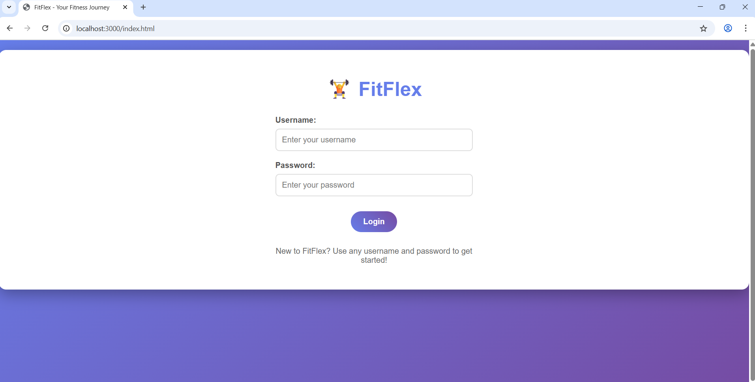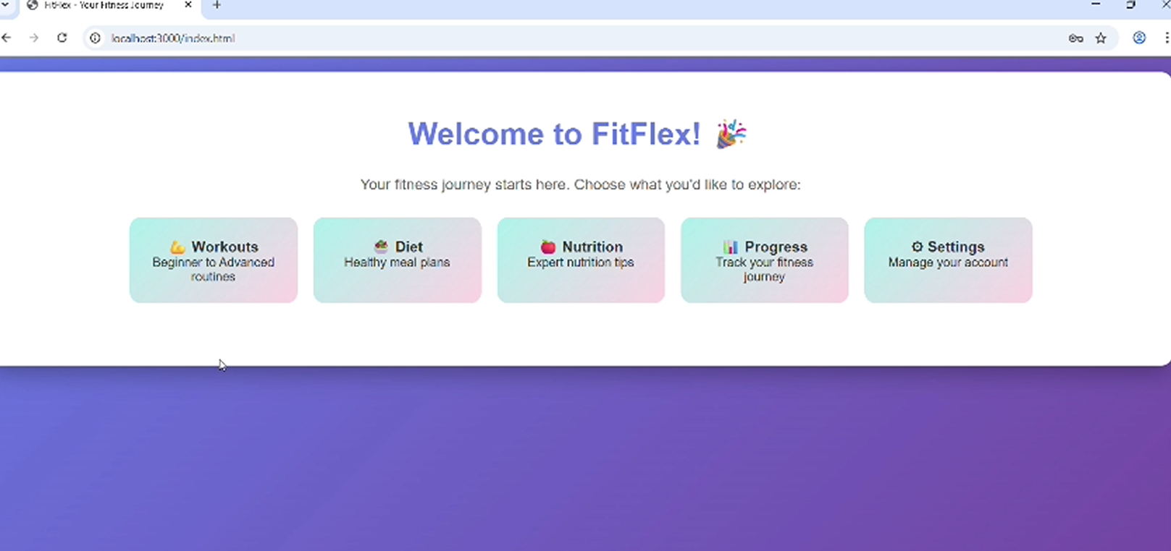

### ***13. Known Issues***

* *Login is simulated, not connected to a real database.*
* *Progress tracking is local and resets when refreshing.*
* *Some pages are static and don’t have dynamic data yet.*

### ***14. Future Enhancements***

* *Add real user authentication (Firebase/Node.js backend).*
* *Enhance progress tracker with charts (Recharts or Chart.js).*
* *Include workout videos and animations.*
* *Mobile-first responsive design improvements.*
* *Gamification features (badges, streak tracking).*